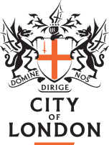
COOLING TOWER INSPECTION TRAINING
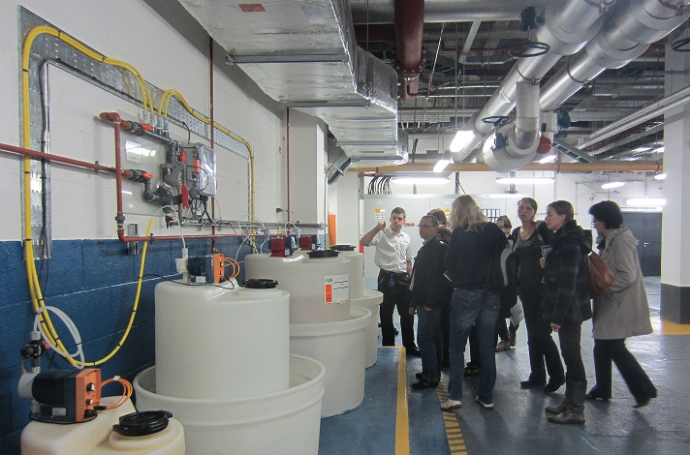
TRAINING

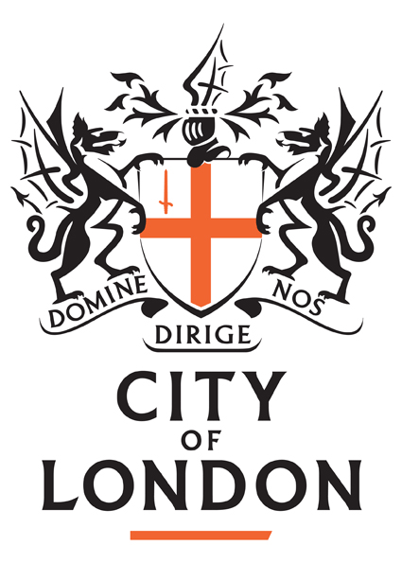
- Our Cooling Tower Inspection Training Course is designed and run with inspecting health & safety practitioners firmly in mind and combines the theoretical with a practical site visit as an integral part of the overall learning experience.

- You will learn:
  - what a cooling tower does
  - about the different types of towers and what the different elements do
  - about water treatment programme options and why they are used
  - the control measures you can expect to be in place
  - about other relevant risks such as work at height and manual handling
  - how to conduct a thorough and safe inspection

- We have trained around 300 health & safety practitioners including EHOs and HSE inspectors from across the whole UK with their feedback being very positive:-

“Course was brilliant. Well delivered and easy to understand. Would recommend”
“The visit to the cooling tower put all the course into perspective”
“Very useful, will pay dividends in the future, a true investment of time”
“Trainer made subject interesting & delivered in a useable way to use info practically & from the viewpoint of an EHO”
“I knew nothing of cooling towers and their inspection before today and I am now reasonably confident to do an inspection”

ABOUT US
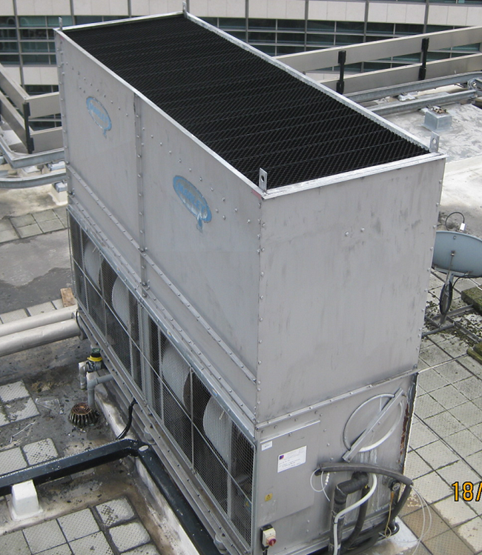
- We are responsible for regulating the largest concentration of cooling towers in Europe at circa 150 sites in the “Square Mile”
- We have been regulating and advising on cooling tower risk management since the early 90’s and sat on the HSE and industry working group that wrote the original L8 ACoP
- We are the sole local authority representatives on the Legionella Control Association Management Committee
- Our officers are regular speakers at legionella industry and regulator forums across the UK

COURSE INFORMATION

The next date is 13th and 20th September 2022 and is a full day of training (inc. lunch). Courses are limited to only ten delegates - please email Kath Lewis admin@alehm.org.uk to reserve a space or book a place on the Alehm website www.alehm.org.uk/courses

